**Physics: 10. Centre of Gravity**

***Please remember to photocopy 4 pages onto one sheet by going A3→A4 and using back to back on the photocopier***

**Syllabus**

**OP8** Find the centre of gravity of a thin lamina

Investigate the role of centre of gravity in design for stability and equilibrium

**Student Notes**

**The Centre of Gravity of an object is the point through all the weight of the object appears to act.**

**Experiment: To find the centre of gravity of a sheet of cardboard.**

1. 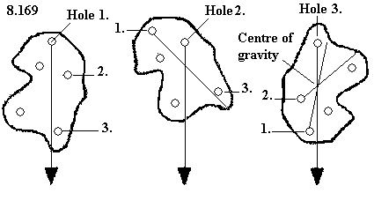Set up as shown.
2. Hang the cardboard from a nail so that it rotate freely.
3. Hang a weight from this point using cord so that the weight hangs straight down.
4. Draw a line to represent the position of the cord.
5. Rotate the sheet of cardboard and repeat.
6. The intersection of the two lines represents the centre of gravity of the object.
7. Now repeat one more time to verify that this line also goes through the same point.

**Stability**

**An object can be made more stable by:**

1. giving it a low centre of gravity
2. giving it a wider base

**An object will topple if a vertical line through its centre of gravity falls outside its base.**

These flamingos may not look stable, but once their centre of gravity is over their base (in this case the area between their feet) then they won’t topple over.

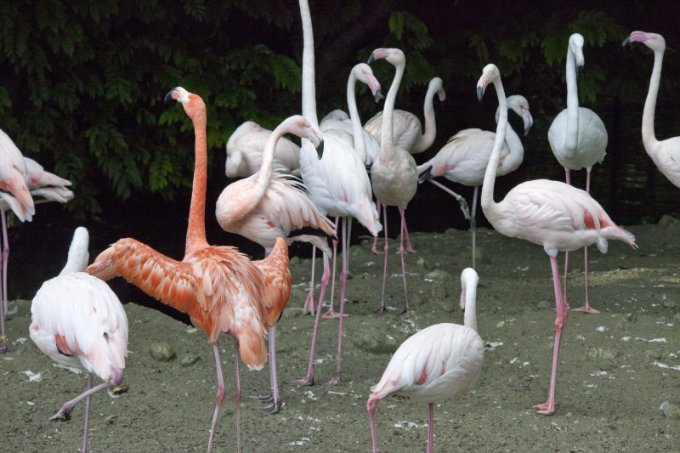

But how do these guys manage to keep their centre of gravity over the base??

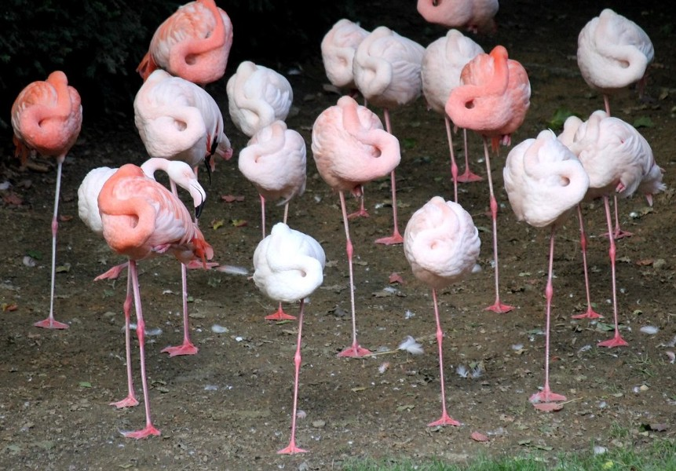

**Demonstration**

Try to balance an empty coke can on its lip – it can’t be done because the centre of gravity is not over the lip.

Now pour a little water into the coke can and try again. This time you should be able to balance it because the water results in the can having a new centre of gravity which is now directly over the lip.

**Test Questions**

1. Define the term ‘Centre of Gravity’.
2. Give two ways in which an object can be made stable.
3. What factor determines whether an object which has been tilted will fall over?
4. Describe briefly how to find the exact centre gravity of an irregular-shaped piece of cardboard (make sure you include a diagram in your answer).
5. Explain why the centre of gravity of a double-decker bus should be as low as possible.

**Teaching *Centre of gravity***

**Syllabus**

**OP8**

Find the centre of gravity of a thin lamina; Investigate the role of centre of gravity in design for stability and equilibrium

**1.1 Find the centre of gravity of a thin lamina**

Step one is to explain that **the centre of gravity of an object is the point through which all the weight of the object appears to act.**

**Experiment: Find the centre of gravity of a thin lamina (like an irregular-shaped piece of cardboard)**

Students can make their own lamina using cardboard. Part of the fun is designing the irregular shape (girls like teddy-bear shapes) but it’s important that the shape is not so irregular that the centre of gravity lies *outside* the object.

Rather than try to draw the lines while the lamina is hanging (which is tricky to do) students could mark two points on the line, and then complete the line when they have removed the lamina.

Question:

Why should three lines be drawn when two would suffice to find the centre of gravity?

**1.2 Investigate the role of centre of gravity in design for stability and equilibrium**

* **An object can be made more stable by giving it a low centre of gravity and/or giving it a wider base.**

Why is the centre of gravity of an object important for stability?

Because the lower the centre of gravity of an object, the harder it is to knock it over e.g. it’s easier to knock over a tall person like a basketball player than it is a stocky person like a rugby player.

It’s also easier to overturn a double-decker bus than a racing car.

Can you see why it is so hard to topple a shopping trolley?

* **An object will topple if a vertical line through its centre of gravity falls outside its base.**

**Text-books should highlight this more** and students should have to learn it, because it is the golden rule when considering stability (even though it doesn’t appear to be on the syllabus).

* **Centre of gravity demonstrations**

There are a lot of cool demonstrations on this topic; just google ‘centre of gravity demonstrations’ or look for them on YouTube. The following three are some of the simplest.

1. **Balancing a coke can**

Pour a small amount of water into a coke can and see how easy it is to balance it on its lip.

You need to get a bunch of these so every student can try it.

In this case the surface of the water in the can automatically becomes horizontal resulting in the centre of gravity being directly over the base, and therefore stabilising it.

Trial and error will determine the correct amount of water.

1. **Win €100!**

Get a student to stand against a wall, with their body perpendicular to the wall, and inside foot against the wall. Now tell them that you will give them €100 if they can lift their outside leg for three seconds!

It can’t be done, because as soon as they left their outside leg their centre of gravity is no longer over the base (their inside foot) and they fall.

Cool.

1. **Doubles or quits!**

Get a student to sit upright in a chair with their back straight. Now tell them to get up *without bending forwards*. It can’t be done!

1. **Babies /drunks falling over**

As soon as the person moves one foot out in front he/she is now unstable and will fall over unless they put their leg out in front to stop the fall. Walking is therefore a process of trying to not fall over! This requires quite a considerable amount of coordination, and an even greater amount of coordination to make it look ‘natural’. It remains one of the biggest challenges in robot design.